|  |  |  |  |  |
| --- | --- | --- | --- | --- |
| **MONDAY** | **TUESDAY** | **WEDNESDAY** | **THURSDAY** | **FRIDAY** |
| **2** | **3** | **4** | **5** | **6** |
|  |  |  |  |  |
| **9** | **10** | **11** | **12** | **13** |
|  |  | First day of school! |  | Go Canes!  Image result for hurricane flag clip art |
| **16** | **17** | **18** | **19** | **20** |
| **Sight Words:**  red, the, a, blue |  |  | **Wear RED or BLUE!** | Go Canes!  Image result for hurricane flag clip art |
| **23** | **24** | **25** | **26** | **27** |
| **Sight Words:**  and, is, brown  Image result for book clipart |  |  | **Wear BROWN!** | Go Canes!  Image result for hurricane flag clip art |
| **30** | **31** |  |  |  |
| **Sight Words:**  you, on, yellow  Image result for book clipart | First PTC Meeting 8:15 |  | **Wear YELLOW!** | Go Canes!  Image result for hurricane flag clip art |

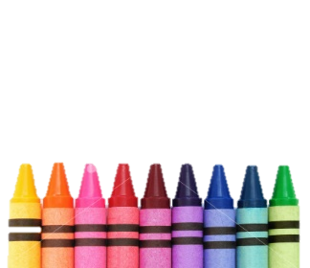

**SPECIALS 12:45 – 1:15**

Monday – Music

Tuesday – PE

Wednesday – PE

Thursday - Computer

Friday – Art

**LUNCH 11:00 – 11:30**

